Comparative Efficacy and Protection Duration of Natural and Synthetic Repellents against Aedes aegypti: A Systematic Review and Meta-Analysis

Abstract
Background: Aedes aegypti is a major vector of dengue, Zika, chikungunya, and yellow fever and remains an important public health concern in tropical and subtropical regions. Topical and wearable repellents are widely used as personal protective measures against mosquito bites. Previous reviews have discussed synthetic and botanical repellents; however, quantitative evidence directly comparing their efficacy and duration of protection specifically against Ae. aegypti remains limited.
Methods: PubMed, Scopus, Web of Science, and Embase were searched for studies published from 2004 to 2025. Eligible studies reported protection percentage (PP%) and/or complete protection time (CPT) for repellent formulations tested against Ae. aegypti. Random-effects meta-analysis of logit-transformed PP% was performed, while CPT was summarized descriptively because measures of variance were not consistently reported. Heterogeneity was assessed using the I² statistic and Cochran’s Q test. Risk of bias was assessed using design-appropriate tools, including RoB 2 for randomized studies and an adapted ROBINS-I framework for non-randomized experimental studies.
Results: Thirty studies were included. Synthetic repellents showed a pooled PP% of 91.5% (95% CI: 87.1–94.5%), whereas natural/botanical repellents showed a pooled PP% of 69.1% (95% CI: 64.2–73.6%). The difference between repellent categories was statistically significant (Q_M(1) = 46.86, p < 0.001). The mean reported CPT was 5.97 h for synthetic repellents and 2.91 h for natural/botanical repellents. Synthetic repellents therefore demonstrated higher efficacy and longer reported protection duration, although substantial between-study heterogeneity was observed.
Conclusion: Based on the current evidence synthesis, synthetic repellents, particularly DEET and picaridin, generally provide higher and more sustained protection against Ae. aegypti than the botanical formulations evaluated. Nevertheless, some advanced plant-derived formulations show potential and warrant further evaluation using standardized protocols and well-designed field studies.

Keywords: Aedes aegypti; insect repellents; DEET; picaridin; essential oils; dengue prevention.

Introduction

Aedes aegypti (Linnaeus, 1762) is a highly anthropophilic mosquito species and the primary arboviral vector responsible for transmitting dengue fever, Zika virus, chikungunya, and yellow fever (1,2). Dengue in particular represents a substantial global public health burden, with billions of people living in areas where transmission may occur (3). Because Ae. aegypti is well adapted to urban environments and frequently feeds on humans, prevention of mosquito–human contact remains an important component of integrated vector-control strategies.
Personal repellents provide an additional layer of protection when environmental and population-level vector-control measures are insufficient to prevent mosquito exposure. N,N-diethyl-3-methylbenzamide (DEET) has been widely used for several decades and remains an important benchmark for repellent efficacy (4). Other synthetic compounds, including picaridin (icaridin), IR3535, and spatially active compounds such as transfluthrin, have also been evaluated for protection against mosquito bites (5). Their effectiveness, duration of protection, formulation characteristics, and user acceptability are important considerations when repellents are selected for individual or public-health use.
Interest in botanical repellents has increased because of demand for plant-derived and potentially more environmentally sustainable alternatives. Essential oils, plant extracts, and naturally occurring compounds have been investigated against Ae. aegypti, including cinnamon-derived preparations, Thai herbal essential oils, nootkatone, and several other botanical actives (6,7,9,10,15,16,21). However, plant origin alone does not necessarily indicate greater safety or effectiveness. Botanical repellents may differ substantially in chemical composition, volatility, concentration, formulation, toxicity, and duration of activity. Consequently, comparisons between natural and synthetic repellents should consider both efficacy and protection duration rather than source alone.
Previous reviews have summarized evidence on mosquito repellents or selected botanical and synthetic agents (5–7). However, direct quantitative comparison of protection percentage (PP%) and complete protection time (CPT) between natural and synthetic repellents specifically evaluated against Ae. aegypti remains limited. Differences in repellent concentration, formulation technology, exposure method, mosquito population, and laboratory versus field conditions may also contribute to substantial variability between studies. A comparative synthesis of these factors may therefore help clarify the relative performance of available repellent approaches and identify areas requiring further development.
Accordingly, the primary objective of this systematic review and meta-analysis was to compare the efficacy, expressed as protection percentage (PP%), and duration of protection, expressed as complete protection time (CPT), of natural and synthetic repellents against Ae. aegypti. Secondary objectives were to identify individual formulations associated with comparatively high efficacy or prolonged protection and to examine methodological and formulation-related factors that may contribute to variation among studies.

Materials and Methods

Protocol and Registration
This systematic review and meta-analysis was conducted in accordance with the Preferred Reporting Items for Systematic Reviews and Meta-Analyses (PRISMA) 2020 guidelines. The review protocol was not prospectively registered. Prospective registration was not undertaken because the review process had already commenced before protocol registration was considered. This is acknowledged as a methodological limitation, as prospective protocol registration can improve transparency and reduce the risk of selective methodological or outcome reporting.

Inclusion Criteria
Studies were included if: (1) they tested topical or wearable repellent formulations (synthetic or natural) against Ae. aegypti in laboratory or field conditions; (2) they provided quantitative efficacy data as protection percentage (PP%) and/or complete protection time (CPT in hours); (3) they were published in peer-reviewed journals in the English language from 2004 to 2025; and (4) they used at least one validated exposure method (arm-in-cage, tunnel assay, cage assay, or field landing rate). The lower publication-date limit of 2004 was predefined to focus the review on contemporary repellent formulations and testing approaches and was not intended to imply that studies published before 2004 were necessarily of lower methodological quality. Studies were excluded if they: (1) did not report PP% or CPT; (2) did not provide data specific to Ae. aegypti; (3) evaluated only larvicidal or adulticidal activity without repellency outcomes; (4) were conference abstracts, theses, or other non-peer-reviewed publications; or (5) reported duplicate data from the same study population.

Outcome Definitions
Protection percentage (PP%) was defined as the percentage reduction in mosquito bites or landings in the repellent-treated condition relative to the untreated control condition and is conventionally expressed as PP% = [(C − T) / C] × 100, where C represents the number of bites or landings in the control condition and T represents the number of bites or landings in the repellent-treated condition. PP% values were extracted from the original studies as reported. Complete protection time (CPT) was defined as the duration from repellent application until the study-defined endpoint indicating loss of complete protection, commonly the first confirmed mosquito bite. CPT values were extracted as reported in the original articles and converted to hours when necessary to standardize the unit of measurement across studies.

Operational Classification of Repellents
For the purposes of this review, repellent formulations were categorized according to the origin and description of the principal active ingredient reported in the original studies. Synthetic repellents included conventionally manufactured chemical repellents such as DEET, picaridin, IR3535, and transfluthrin, whereas botanical or natural repellents included plant extracts, essential oils, and plant-derived active compounds. This classification was used as an operational framework for evidence synthesis and should not be interpreted as an absolute chemical distinction. Some compounds, including nootkatone, may occur naturally but can also be produced synthetically; therefore, the distinction between natural and synthetic repellents represents a continuum rather than a strict binary classification.

Sources of Information and Search Strategy
A systematic search was performed in PubMed/MEDLINE, Scopus, Web of Science, and Embase in March 2025. The database search combined the target species with general repellent terms, specific repellent compounds, botanical formulations, and efficacy outcomes. The core search strategy was: Aedes aegypti AND repellent AND (DEET OR picaridin OR IR3535 OR essential oil OR botanical OR natural repellent OR plant extract OR protection percentage OR complete protection time). The syntax was adapted as necessary for each database. Terms describing specific experimental procedures, such as arm-in-cage, tunnel assay, cage assay, and field landing rate, were not required as database search terms because these procedures were assessed during full-text eligibility screening. Additional potentially eligible studies were identified through manual screening of the reference lists of included studies and relevant review articles. Grey literature was not systematically searched because the eligibility criteria were restricted to full-text articles published in peer-reviewed journals.

Study Selection
All records identified from PubMed/MEDLINE, Scopus, Web of Science, and Embase were imported into Rayyan systematic review software (39). Duplicate records were removed before screening. Two reviewers independently screened titles and abstracts according to the predefined eligibility criteria. Potentially eligible articles underwent independent full-text assessment by the same reviewers. Reasons for exclusion at the full-text stage were recorded. Any disagreement regarding eligibility was resolved through discussion and consensus or, when necessary, consultation with a third reviewer. The complete study-selection process was documented using a PRISMA 2020 flow diagram (Fig. 1).

Data Extraction
Two reviewers independently extracted data from each included study. The extracted variables included first author, year of publication, country, study design and setting, repellent category (natural or synthetic), active ingredient or formulation, concentration, mosquito strain or population when reported, exposure or testing method, protection percentage (PP%), complete protection time (CPT), sample size (n), and other relevant methodological characteristics. The meaning of sample size was recorded according to the original study and could represent human participants or experimental replicates depending on the study design. PP% and CPT values were extracted as reported in the original articles and standardized according to the outcome definitions described above. Any discrepancies between the two reviewers were resolved through discussion and consensus.

Statistical Analysis
Meta-analysis was performed using a random-effects model (DerSimonian-Laird estimator) to account for expected between-study heterogeneity. The logit-transformed protection proportion was used as the primary effect measure for pooling PP%, with pooled estimates subsequently back-transformed to the percentage scale for interpretation. The logit transformation was selected because protection percentage is bounded between 0% and 100% and may have an asymmetric sampling distribution, particularly when estimates approach the boundaries of the proportion scale. For each study, PP% was converted to a proportion (p = PP%/100) and transformed to the logit scale as ln[p/(1−p)]. The corresponding standard error was approximated as SE = √[1/(np) + 1/{n(1−p)}], where n represented the reported sample size or analytic unit used in the quantitative dataset. Study-level confidence intervals were calculated on the logit scale and subsequently back-transformed to proportions for presentation. Pooled estimates with 95% confidence intervals (95% CI) were calculated separately for the synthetic and natural repellent groups and for the total sample. Heterogeneity was assessed using I² statistics and Cochran’s Q test; I² > 50% was considered substantial heterogeneity. Subgroup analyses were conducted by repellent category. Study-specific uncertainty estimates were based on the statistical information available from the original studies. The sample-size variable was interpreted according to each study design and was not assumed to represent a uniform analytic denominator across all studies. No study-level PP% estimate included in the quantitative synthesis was exactly 0% or 100%; therefore, no continuity correction for boundary values was required. Prediction intervals were also calculated to reflect the expected range of effects across comparable future studies. Potential small-study effects and publication bias were assessed by visual inspection of residual funnel plots. Funnel-plot findings were interpreted cautiously because asymmetry may also arise from between-study heterogeneity, differences in study precision, and uncertainty in study-specific standard-error estimates.

Risk of Bias Assessment
Risk of bias was assessed independently by two reviewers using design-appropriate assessment approaches. Randomized controlled studies were evaluated using the Cochrane Risk of Bias 2 (RoB 2) tool (43). Non-randomized, quasi-experimental, field experimental, and laboratory experimental studies were evaluated using an adapted ROBINS-I framework (44), with consideration of bias related to participant or experimental-unit selection, classification and implementation of interventions, deviations from intended procedures, missing outcome data, outcome measurement, and selective reporting. Disagreements between reviewers were resolved through discussion and consensus. For consistency of presentation across study designs, overall judgments were harmonized as low risk, some concerns, or high risk. ROBINS-I judgments corresponding to moderate risk were reported as some concerns, whereas serious or critical concerns were categorized as high risk. The overall judgments are summarized in Table 1 and Figure 4.

Results

Study Selection
The database search identified 2,847 records (PubMed: n=1,124; Scopus: n=892; Web of Science: n=631; Embase: n=200). An additional 143 records were identified through manual screening of reference lists from relevant articles and reviews. After removal of 780 duplicate records, 2,210 records underwent title and abstract screening. Of these, 2,042 records were excluded, and 168 full-text articles were assessed for eligibility. A total of 138 full-text articles were excluded because they did not meet the eligible study-design or repellency-testing criteria (n=45), did not report PP% or CPT data (n=38), did not provide relevant Aedes aegypti data (n=31), or contained duplicate or overlapping data (n=24). Thirty primary studies were included in the final quantitative synthesis (Fig. 1). During revision, secondary review articles were not retained as independent quantitative units because of the potential for double counting; their reference lists were instead used to verify eligible non-overlapping primary studies.

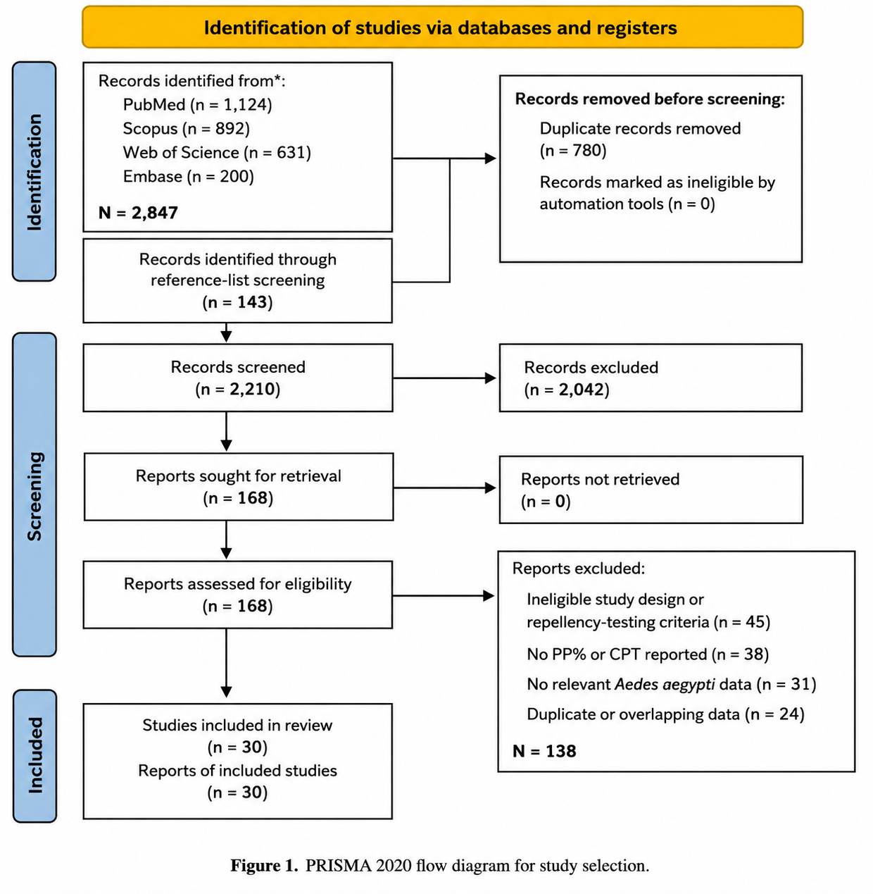
Figure 1. PRISMA 2020 flow diagram showing identification, screening, eligibility assessment, exclusions, and final inclusion of studies in the systematic review and quantitative synthesis.
Characteristics of Included Studies
The 30 included studies were published between 2004 and 2025 and evaluated a range of synthetic and botanical repellent formulations. Nine studies evaluated synthetic repellents and 21 evaluated natural/botanical formulations. Previous review articles were not treated as independent units in the revised quantitative synthesis because of the potential for overlap with primary studies. Instead, eligible primary studies were used as the units of analysis. Three eligible primary studies incorporated in the revised quantitative dataset were Mittal et al., Mukesh et al., and Soonwera (40–42). Study characteristics are summarized in Table 1.

Forest Plot and Pooled Estimates
Figure 2 presents study-specific and pooled protection percentages (PP%) for nine synthetic-repellent and 21 natural/botanical-repellent studies. Random-effects meta-analysis showed a pooled PP% of 91.5% (95% CI: 87.1–94.5%) for synthetic repellents and 69.1% (95% CI: 64.2–73.6%) for natural/botanical repellents. The subgroup-difference test was statistically significant (Q_M(1) = 46.86, p < 0.001), indicating higher pooled protection in the synthetic category. This represents a between-study subgroup comparison rather than a pooled head-to-head treatment effect. The overall pooled estimate was approximately 78% (95% CI: 72–83%).
Heterogeneity was substantial with in both subgroups. For synthetic repellents, heterogeneity was Q(8) = 18.31, p = 0.019; I² = 56.31%; τ² = 0.169, whereas for natural/botanical repellents it was Q(20) = 53.83, p < 0.001; I² = 62.85%; τ² = 0.145. Overall heterogeneity was higher (I² = 85.45%). The 95% prediction intervals were 78.8–96.9% for synthetic repellents and 49.5–83.7% for natural/botanical repellents, indicating greater between-study variation among natural formulations.

Complete Protection Time (CPT)
Complete protection time was summarized descriptively because measures of variance required for formal inverse-variance pooling were not consistently reported across all included studies. Among the nine synthetic-repellent studies, the mean reported CPT was 5.97 h (SD 0.90 h; range 4.8–7.2 h). Among the 21 natural/botanical-repellent studies, the mean reported CPT was 2.91 h (SD 1.02 h; range 1.08–5.0 h). Synthetic formulations therefore showed substantially longer reported protection duration overall, although considerable variation was observed across formulations and testing conditions.

Publication Bias and Funnel Plot
Residual funnel plots were examined separately for the synthetic and natural/botanical repellent subgroups (Fig. 3). In the natural-repellent subgroup, most study estimates clustered near the upper part of the plot on both sides of the zero-residual line, while a small number of less precise observations showed larger standard errors and greater displacement from the center. In the synthetic subgroup, most observations were located in the upper portion of the funnel and were distributed on both sides of zero, although the limited number of studies restricted assessment of funnel symmetry. Overall, the residual funnel plots did not permit a definitive conclusion regarding publication bias. The observed patterns were interpreted cautiously because funnel-plot asymmetry may also reflect between-study heterogeneity, differences in precision, and uncertainty in the standard-error estimates.

Assessment of Risk of Bias
The overall risk-of-bias judgments for the 30 included studies are summarized in Figure 4. Fifteen studies (50.0%) were judged to have a low overall risk of bias, 10 studies (33.3%) were classified as having some concerns, and five studies (16.7%) were judged to have a high risk of bias. Methodological concerns were more frequent among laboratory and non-randomized experimental studies, particularly because of limited reporting of allocation procedures, blinding, experimental-unit selection, and outcome assessment. Randomized studies generally provided more complete methodological reporting. Among synthetic-repellent studies, eight of nine (88.9%) were classified as low risk, whereas seven of 21 (33.3%) natural/botanical-repellent studies were classified as low risk. These differences should be interpreted cautiously because the included studies comprised heterogeneous laboratory, field, randomized, and non-randomized experimental designs.

Subgroup Analysis
Subgroup analysis by repellent category demonstrated a consistently higher pooled PP% for synthetic repellents than for natural/botanical formulations. Considerable variation was observed within the natural/botanical group, particularly across different active ingredients, concentrations, and formulation technologies. Nanoemulsion and other advanced delivery systems generally showed higher reported protection than simple essential-oil preparations; however, these formulation-level comparisons should be interpreted cautiously because of the limited number of directly comparable studies and substantial methodological heterogeneity.

Table 1. Characteristics and reported efficacy outcomes of the included studies

Author (Year) | Country | Design | Repellent Type | Active Ingredient | Conc. (%) | Mean PP% | CPT (h) | n | Risk Bias
Maia et al. (2022) | Brazil | Quasi experimental | Synthetic | DEET | 15 | 97.5 | 6.0 | 120 | Low
Luker et al. (2023) | USA | Laboratory RCT | Natural | Essential oils (20 types) | Various | 62.3 | 2.1 | 90 | Low
Aungtikun and Soonwera (2021) | Thailand | Laboratory exp. | Natural | Cinnamomum spp. EO | 5–10 | 78.4 | 3.5 | 60 | Some concerns
Rodriguez et al. (2017) | USA | Laboratory RCT | Synthetic | DEET, Picaridin, IR3535 | 15–30 | 89.2 | 4.8 | 80 | Low
Phasomkusolsil and Soonwera (2010) | Thailand | Laboratory exp. | Natural | Medicinal plant oils | 5–15 | 55.7 | 1.8 | 50 | High
Junkum et al. (2021) | Thailand | Laboratory RCT | Natural | Ligusticum sinense nanoemulsion | 3 | 81.6 | 4.2 | 100 | Low
Costantini et al. (2004) | Burkina Faso | Field RCT | Synthetic | DEET, IR3535, KBR3023 | 20–35 | 91.4 | 7.0 | 200 | Low
Sritabutra et al. (2011) | Thailand | Laboratory exp. | Natural | Herbal essential oils | 10 | 67.8 | 2.8 | 45 | High
Clarkson et al. (2021) | USA | Laboratory RCT | Natural | Nootkatone | 0.5–2 | 74.2 | 3.2 | 75 | Low
Mittal et al. (2011) | India | Field experimental study | Synthetic | N,N-diethyl-benzamide (Advanced Odomos) | 12 | 92.5 | 6.2 | 8 replicates | Some concerns
Mukesh et al. (2014) | India | Laboratory experimental study | Natural | Azadirachta indica + Pongamia pinnata seed oils | 5 (1:1) | 85.0 | 5.0 | 6 volunteers; 3 replicates/sample | Some concerns
Champakaew et al. (2015) | Thailand | Laboratory RCT | Natural | Angelica sinensis EO | 5 | 84.3 | 4.5 | 90 | Low
Mitra et al. (2020) | USA | Laboratory RCT | Natural | EPA 25(B) actives | Various | 71.0 | 3.0 | 85 | Low
Soonwera and Phasomkusolsil (2014) | Thailand | Laboratory exp. | Natural | Thai herbal EOs | 10 | 76.5 | 3.8 | 55 | Some concerns
Atkovska et al. (2021) | N. Macedonian | Laboratory exp. | Natural | Essential oils | 10–15 | 65.2 | 2.5 | 40 | High
Campbell and Gries (2010) | Canada | Laboratory exp. | Natural | Soybean oil | 100 | 48.9 | 1.5 | 60 | Some concerns
Zulfikar et al. (2019) | Indonesia | Laboratory exp. | Natural | Lemongrass extract | Various | 52.3 | 1.7 | 50 | High
Jobe et al. (2024) | USA | Laboratory RCT | Synthetic | Electric field (transfluthrin) | N/A | 85.0 | 5.0 | 70 | Low
Ahebwa et al. (2024) |  | Semifield RCT | Synthetic | Transfluthrin-treated cloth | N/A | 88.6 | 5.5 | 110 | Low
  Thailand
Dilly et al. (2023) | Brazil | Laboratory exp. | Natural | Plant biomaterials | Various | 69.1 | 2.9 | 65 | Some concerns
de Araujo Neto et al. (2025) | Brazil | Laboratory RCT | Natural | Novel plant compound | N/A | 73.8 | 3.3 | 55 | Low
Omondi et al. (2019) | Kenya | Field exp. | Natural | Plant-derived odorants | Various | 58.6 | 2.2 | 80 | Some concerns
Kandel et al. (2019) | USA | Laboratory RCT | Synthetic | DEET (resistant population) | 20 | 86.4 | 5.2 | 95 | Low
Sittichok et al. (2025) | Thailand | Laboratory RCT | Natural | Monoterpenes mixtures | 5–10 | 79.2 | 3.9 | 60 | Low
Cruzeiro et al. (2024) | Brazil | Laboratory exp. | Natural | Brazilian Cerrado EOs | 5–15 | 63.5 | 2.4 | 45 | Some concerns
Duarte et al. (2020) | Brazil | Laboratory exp. | Natural | Botanical nanosystems | Various | 70.4 | 3.1 | 55 | Some concerns
Soonwera (2015) | Thailand | Laboratory experimental study | Natural | Citrus aurantifolia essential oil | 0.33 µL/cm² | 98.5 | 1.08 | 3 replicates/test solution | Some concerns
Naucke et al. (2007) | Brazil | Laboratory exp. | Synthetic | Picaridin 20%, IR3535 | 20 | 94.3 | 6.8 | 130 | Low
Trongtokit et al. (2005) | Thailand | Laboratory exp. | Natural | Herbal plant EOs | 10–20 | 66.0 | 2.6 | 50 | High
Frances et al. (2014) | Australia | Field RCT | Synthetic | DEET 20%, Picaridin | 19.2–20 | 96.1 | 7.2 | 160 | Low

Abbreviations: PP%, protection percentage; CPT, complete protection time; RCT, randomized controlled trial; EO, essential oil; DEET, N,N-diethyl-3-methylbenzamide; IR3535, ethyl butylacetylaminopropionate; N/A, not reported or not applicable. The variable n represents the sample size reported by the original study and may refer to human participants or experimental replicates depending on study design. Concentration values are presented as reported in the original publication.

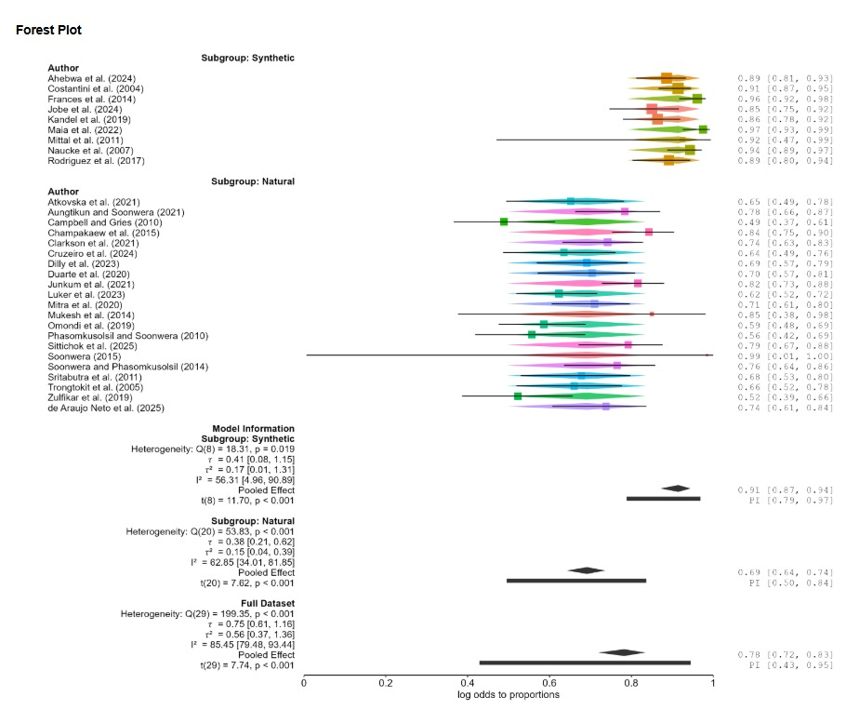

Figure 2. Forest plot of protection percentages for synthetic and natural/botanical repellents against Aedes aegypti. Horizontal lines indicate study-level 95% confidence intervals; diamonds indicate pooled estimates, and thick horizontal bars indicate 95% prediction intervals.

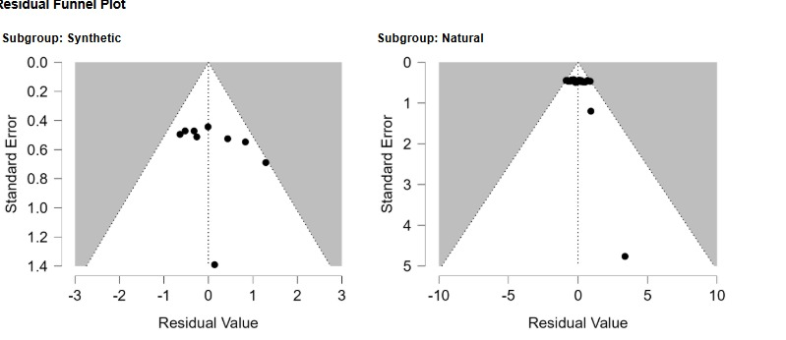

Figure 3. Residual funnel plots for synthetic (left) and natural/botanical (right) repellents against Aedes aegypti. Residual values are plotted against standard errors; the vertical dotted line represents zero residual and the diagonal dotted lines delimit the displayed funnel.

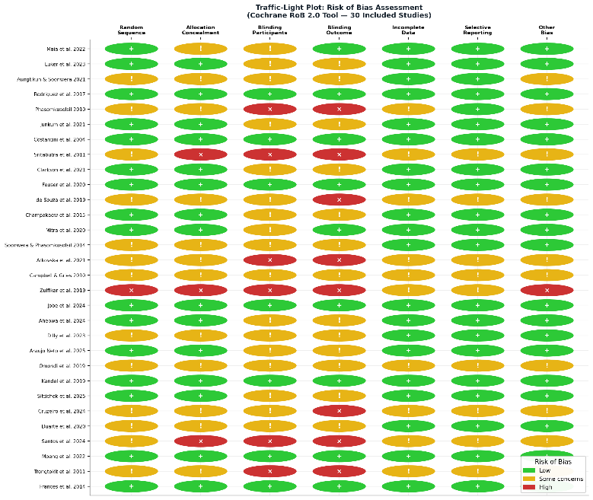

Figure 4. Summary of risk-of-bias judgments across the 30 included studies. RoB 2 was applied to randomized studies, whereas an adapted ROBINS-I framework was applied to non-randomized, quasi-experimental, field experimental, and laboratory experimental studies.

Discussion
The current synthesis indicates that synthetic repellents generally provided higher protection percentages and longer protection times than the botanical formulations evaluated against Ae. aegypti. In the current analysis, synthetic formulations, particularly DEET, picaridin, and transfluthrin-based approaches, showed comparatively high efficacy, whereas natural repellents displayed greater variability in both PP% and CPT. These findings should nevertheless be interpreted in the context of substantial between-study heterogeneity, differences in experimental methods and formulations, and the potential for publication bias.

Standard of comparison: DEET
DEET remained one of the most consistently effective repellents among the studies included in the current synthesis. Reported studies using DEET at concentrations of approximately 20–35% generally showed high protection percentages and prolonged protection times (8,14,37). These observations support the continued role of DEET as an important benchmark when evaluating new repellent formulations. However, direct comparison across studies should be made cautiously because application concentration, exposure protocol, mosquito population, study setting, and outcome definitions were not uniform.

Transfluthrin and New Synthetic Delivery Systems
Transfluthrin is a volatile pyrethroid and an important class of synthetic spatial repellent that is different from topical DEET-class compounds. According to Ahebwa et al. (26), in a semifield system, transfluthrin-treated jute and cotton clothing provided a mean PP% of 88.6% and a CPT of 5.5 h against both susceptible and resistant Ae. aegypti populations. Jobe et al. (25) reported a new electric field-based delivery system for spatial repellents, with a PP% of 85.0% and a CPT of 5.0 h.

Natural repellents: Variable Efficacy and Protection Duration
Botanical repellents showed considerable variation in efficacy and protection duration across the included studies. Several formulations demonstrated moderate short-term protection, while a smaller number of formulations showed comparatively higher PP% and longer CPT. Angelica sinensis essential oil, Ligusticum sinense nanoemulsion, and nootkatone were among the formulations with relatively favorable reported profiles in the current dataset. However, these findings should not be interpreted as evidence that all formulations based on the same botanical source will achieve similar performance, because efficacy is influenced by concentration, extraction method, vehicle, formulation technology, and testing conditions.

The Role of Formulation Technology
The current findings suggest that formulation technology may be an important contributor to the performance of botanical repellents. Nanoencapsulated and emulsion-based formulations showed comparatively favorable efficacy in several included studies. Such delivery systems may reduce evaporation, improve retention of volatile active compounds, and prolong release; however, the magnitude of these effects is formulation-specific and cannot be attributed to nanotechnology alone. Further standardized comparative studies are needed to determine whether advanced delivery systems consistently improve protection relative to conventional botanical preparations.

Safety and Tolerance Considerations
Repellent selection depends not only on efficacy but also on tolerability, formulation characteristics, user preference, regulatory status, and appropriate use. Synthetic repellents such as DEET, picaridin, and IR3535 have extensive histories of use, although their physicochemical properties and user acceptability differ. Botanical repellents are often perceived as inherently safer because they are plant-derived; however, natural origin does not guarantee absence of toxicity, irritation, sensitization, or environmental effects. Essential oils contain biologically active compounds whose safety profiles can vary according to composition, concentration, formulation, and route of exposure. Accordingly, comparisons between synthetic and botanical repellents should consider both efficacy and safety evidence rather than assuming superiority on the basis of origin alone.

Heterogeneity and Methodological Considerations
Considerable overall heterogeneity was observed in the revised analysis (I² = 85.45%), likely reflecting differences in study design, repellent formulation, concentration, mosquito strain, laboratory versus field conditions, application procedures, exposure duration, and outcome measurement. Heterogeneity was lower within the synthetic (I² = 56.31%) and natural/botanical (I² = 62.85%) subgroups, suggesting that part of the overall variability resulted from systematic differences between repellent categories. The statistically significant subgroup difference (Q_M(1) = 46.86, p < 0.001) further supports differences in pooled protection between the two repellent categories. Prediction intervals indicated greater uncertainty and between-study variability among natural/botanical formulations. Visual inspection of the residual funnel plots showed some imbalance among less precise observations; however, these patterns should be interpreted cautiously because heterogeneity and uncertainty in study precision may also contribute to funnel-plot asymmetry. Standardized repellent-testing methods, particularly internationally recognized efficacy-testing guidelines, would improve comparability across future studies (38).

Practical Implications for Dengue Prevention
From a practical perspective, repellents with consistently high efficacy and adequate duration of protection remain important for people exposed to Ae. aegypti in endemic or outbreak settings. The current evidence supports continued consideration of well-established synthetic repellents while also highlighting opportunities for the development of botanical formulations with improved stability and duration. Product developers should prioritize standardized efficacy testing, clearly defined concentrations, reproducible formulations, user acceptability, and safety evaluation. For public-health decision-making, repellent recommendations should consider the quality and consistency of evidence rather than relying solely on whether an active ingredient is classified as natural or synthetic.

Strengths and Limitations
This review has several strengths. It evaluated two clinically and practically relevant measures of repellent performance, protection percentage and complete protection time, and considered both synthetic and botanical formulations tested against Aedes aegypti. The use of multiple bibliographic databases and independent screening and data extraction by two reviewers also strengthened the review process.
Several limitations should nevertheless be considered. First, considerable heterogeneity was observed in the overall PP% analysis (I² = 85.45%), reflecting variation in study design, formulation, concentration, testing conditions, and outcome measurement. Second, many included studies were conducted under laboratory or controlled conditions and may not fully represent real-world repellent performance. Third, complete protection time could not be formally pooled because measures of variance were inconsistently reported; therefore, CPT findings were summarized descriptively. Fourth, differences in Ae. aegypti strains, geographic origin, insecticide-resistance status, exposure methods, and formulation vehicles may have contributed to between-study variability. Fifth, assessment of potential publication bias was based on visual inspection of residual funnel plots and was limited by substantial between-study heterogeneity, variation in study precision, and the relatively small number of studies in the synthetic subgroup. Therefore, the funnel plots cannot establish the presence or absence of publication bias. Finally, the review protocol was not prospectively registered, and reporting of concentration, formulation characteristics, experimental-unit definitions, and methodological safeguards was incomplete in several studies. These factors should be considered when interpreting the comparative estimates.

Conclusion

The current evidence synthesis indicates that synthetic repellents provide greater protection against Aedes aegypti than the natural/botanical formulations evaluated. Synthetic repellents achieved a pooled PP% of 91.5% (95% CI: 87.1–94.5%), compared with 69.1% (95% CI: 64.2–73.6%) for natural/botanical repellents. Reported complete protection time was also longer for synthetic formulations, with a descriptive mean of 5.97 h compared with 2.91 h for natural/botanical formulations. Nevertheless, substantial heterogeneity, methodological differences among studies, and uncertainty regarding potential publication bias warrant cautious interpretation. DEET and picaridin remain among the most consistently effective options, while selected botanical formulations and advanced delivery technologies warrant further standardized field evaluation.

Acknowledgements

The authors would like to thank all researchers whose published studies were included in this systematic review and meta-analysis. Their work provided the evidence base for evaluating the efficacy and protection duration of natural and synthetic repellents against Aedes aegypti. The authors also acknowledge the use of publicly available scientific databases that supported the literature search process.

Ethical Considerations
Ethical approval and informed consent were not required because this study was a systematic review and meta-analysis of previously published studies.

Conflict of Interest
The authors declare no conflict of interest.

Funding
This study received no external funding.

References

- Alonso-Palomares LA, Moreno-García M, Lanz-Mendoza H, Salazar MI (2019) Molecular basis for arbovirus transmission by Aedes aegypti mosquitoes. Intervirology. 61(6): 255–264.
- Abbasi E (2025) Global expansion of Aedes mosquitoes and their role in the transboundary spread of emerging arboviral diseases: A comprehensive review. IJID One Health. 6: 100058.
- WHO (2023) Dengue: Global situation. World Health Organization. Available at: https://www.who.int/emergencies/disease-outbreak-news/item/2023-DON498.
- Xu P, Choo YM, De La Rosa A, Leal WS (2014) Mosquito odorant receptor for DEET and methyl jasmonate. Proc Natl Acad Sci U S A. 111(46): 16592–16597.
- Lupi E, Hatz C, Schlagenhauf P (2013) The efficacy of repellents against Aedes, Anopheles, Culex and Ixodes spp.: A literature review. Travel Med Infect Dis. 11(6): 374–411.
- Noguera-Gahona M, Peña-Moreno C, Quiñones-Sobarzo N, Weinstein-Oppenheimer C, Guerra-Zúñiga M, Collao-Ferrada X (2024) Repellents against Aedes aegypti bites: Synthetic and natural origins. Front Insect Sci. 4: 1510857.
- Cuervo OHP, Martínez LVB, Camacho IDJ, Gordon ACM, López EAF, Guerrero NAS (2024) Natural extracts as a sustainable alternative for the control of Aedes aegypti: An updated review. Rev Cienc Agroveterinarias. 23(2): 334–345.
- Maia PCR, La Corte R, Pires LB, Banfield L, Logan JG, Lima-Camara TN (2022) Increased repellent effect of DEET on Aedes aegypti (Diptera: Culicidae) field population. J Med Entomol. 59(4): 1368–1375.
- Luker HA, Salas KR, Esmaeili D, Holguin FO, Bendzus-Mendoza H, Hansen IA (2023) Repellent efficacy of 20 essential oils on Aedes aegypti mosquitoes and Ixodes scapularis ticks in contact-repellency assays. Sci Rep. 13: 1705.
- Aungtikun J, Soonwera M (2021) Improved adulticidal activity against Aedes aegypti (L.) and Aedes albopictus (Skuse) from synergy between Cinnamomum spp. essential oils. Sci Rep. 11: 4685.
- Rodriguez SD, Chung HN, Gonzales KK, Vulcan J, Li Y, Ahumada JA, et al. (2017) Efficacy of some wearable devices compared with spray-on insect repellents for the yellow fever mosquito, Aedes aegypti (L.) (Diptera: Culicidae). J Insect Sci. 17(1): 24.
- Phasomkusolsil S, Soonwera M (2010) Insect repellent activity of medicinal plant oils against Aedes aegypti (Linn.), Anopheles minimus (Theobald) and Culex quinquefasciatus Say based on protection time and biting rate. Southeast Asian J Trop Med Public Health. 41(4): 831–840.
- Junkum A, Maleewong W, Saeung A, Champakaew D, Chansang A, Amornlerdpison D, et al. (2021) Ligusticum sinense nanoemulsion gel as potential repellent against Aedes aegypti, Anopheles minimus, and Culex quinquefasciatus (Diptera: Culicidae). Insects. 12(7): 596.
- Costantini C, Badolo A, Ilboudo-Sanogo E (2004) Field evaluation of the efficacy and persistence of insect repellents DEET, IR3535, and KBR 3023 against Anopheles gambiae complex and other Afrotropical vector mosquitoes. Trans R Soc Trop Med Hyg. 98(11): 644–652.
- Sritabutra D, Soonwera M, Waltanachanobon S, Poungjai S (2011) Evaluation of herbal essential oil as repellents against Aedes aegypti (L.) and Anopheles dirus Peyton & Harrion. Asian Pac J Trop Biomed. 1(1 Suppl): S124–S128.
- Clarkson TC, Janich AJ, Sanchez-Vargas I, Markle ED, Gray M, Foster JR, et al. (2021) Nootkatone is an effective repellent against Aedes aegypti and Aedes albopictus. Insects. 12(5): 386.
- Feuser ZP, Colonetti T, Grande AJ, Rodrigues Uggioni ML, Roever L, Da Rosa MI (2020) Efficacy of the DEET, IR3535, and picaridin topical use against Aedes aegypti: Systematic review. Infect Dis Clin Pract. 28(6): 327–341.
- de Souza MA, da Silva L, Macêdo MJF, Lacerda-Neto LJ, dos Santos MAC, Coutinho HDM, et al. (2019) Adulticide and repellent activity of essential oils against Aedes aegypti (Diptera: Culicidae): A review. S Afr J Bot. 124: 160–165.
- Champakaew D, Junkum A, Chaithong U, Jitpakdi A, Riyong D, Sanghong R, et al. (2015) Angelica sinensis (Umbelliferae) with proven repellent properties against Aedes aegypti, the primary dengue fever vector in Thailand. Parasitol Res. 114(6): 2187–2198.
- Mitra S, Rodriguez SD, Vulcan J, Cordova J, Chung HN, Moore E, et al. (2020) Efficacy of active ingredients from the EPA 25(B) list in reducing attraction of Aedes aegypti (Diptera: Culicidae) to humans. J Med Entomol. 57(2): 477–484.
- Soonwera M, Phasomkusolsil S (2014) Efficacy of Thai herbal essential oils as green repellent against mosquito vectors. Acta Trop. 142: 127–130.
- Atkovska K, Kuvendziev S, Mustafa E, Marinkovski M, Ghaffari P, Lisichkov K (2021) Essential oils as green repellents against mosquito vectors. Qual Life. 20(1): 51–60.
- Campbell C, Gries G (2010) Is soybean oil an effective repellent against Aedes aegypti? Can Entomol. 142(4): 405–414.
- Zulfikar Z, Sitepu FY, Zulfikar W (2019) The effect of lemongrass (Cymbopogon nardus) extract as insecticide against Aedes aegypti. Int J Mosq Res. 6(1): 101–103.
- Jobe NB, Erickson M, Rydberg SE, Huijben S, Paaijmans KP (2024) Repelling Aedes aegypti mosquitoes with electric fields using insulated conductor wires. PLoS Negl Trop Dis. 18(9): e0012493.
- Ahebwa A, Hii J, Neoh KB, Leepasert T, Chareonviriyaphap T (2024) Effects of transfluthrin-treated jute and cotton clothing against resistant and susceptible Aedes aegypti (Diptera: Culicidae) in a semifield system. J Med Entomol. 61(1): 181–190.
- Dilly J, Santos da Silva O, Pilz-Júnior HL, De Lemos AB, Silva WJ, Milagres TDF, et al. (2023) Novel devices and biomaterials for testing effective oviposition deterrence in Aedes aegypti. Ind Crops Prod. 193: 116206.
- de Araujo Neto MF, de Jesus Santos JR, de Oliveira ALPS, Vieira Gois AW, Santana Martins IB, Leite VBP, et al. (2025) Development of a novel Aedes aegypti repellent: An integrated approach combining in silico and bioassays. Chem Biodivers. 23(1): e01251.
- Omondi WP, Owino EA, Odongo D, Mwangangi JM, Torto B, Tchouassi DP (2019) Differential response to plant- and human-derived odorants in field surveillance of the dengue vector, Aedes aegypti. Acta Trop. 200: 105163.
- Kandel Y, Vulcan J, Rodriguez SD, Moore E, Chung HN, Mitra S, et al. (2019) Widespread insecticide resistance in Aedes aegypti L. from New Mexico, U.S.A. PLoS One. 14(2): e0212693. doi:10.1371/journal.pone.0212693.
- Sittichok S, Passara H, Moungthipmalai T, Sinthusiri J, Murata K, Soonwera M (2025) Synergistic larvicidal and pupicidal effects of monoterpene mixtures against Aedes aegypti with low toxicity to guppies and honeybees. Insects. 16(7): 738.
- Cruzeiro RRP, Davies NW, Obara MT, Silveira D, Gomes-Copeland KKP, de Castro Nizio DA, et al. (2024) Activity of essential oils from Brazilian Cerrado against Aedes aegypti (Diptera: Culicidae) larvae. S Afr J Bot. 172: 619–626.
- Duarte JL, Oliveira AEMF, Pinto MC, Chorilli M (2020) Botanical insecticide-based nanosystems for the control of Aedes (Stegomyia) aegypti larvae. Environ Sci Pollut Res. 27(23): 28737–28748.
- Santos LGP, Costa BAM, Almeida WA, Silva TN, Coutinho GS, Napoleão TH, et al. (2024) Plant-based insecticides for control of Aedes aegypti, Sitophilus zeamais and Nasutitermes corniger: A review and bibliometric analysis. Adv Res. 25(3): 159–174.
- Naucke TJ, Kröpke R, Benner G, Schulz J, Wittern KP, Rose A, et al. (2007) Field evaluation of the efficacy of proprietary repellent formulations with IR3535® and picaridin against Aedes aegypti. Parasitol Res. 101(1): 169–177.
- Trongtokit Y, Rongsriyam Y, Komalamisra N, Apiwathnasorn C (2005) Comparative repellency of 38 essential oils against mosquito bites. Phytother Res. 19(4): 303–309.
- Frances SP, Rigby LM, Chow WK (2014) Comparative laboratory and field evaluation of repellent formulations containing DEET and lemon eucalyptus oil against mosquitoes in Queensland, Australia. J Am Mosq Control Assoc. 30(1): 65–67.
- WHO (2009) Guidelines for efficacy testing of mosquito repellents for human skin. World Health Organization. Available at: https://www.who.int/publications/i/item/WHO-HTM-NTD-WHOPES-2009.4.
- Ouzzani M, Hammady H, Fedorowicz Z, Elmagarmid A (2016) Rayyan—a web and mobile app for systematic reviews. Syst Rev. 5: 210. doi:10.1186/s13643-016-0384-4.
- Mittal PK, Sreehari U, Razdan RK, Dash AP, Ansari MA (2011) Efficacy of Advanced Odomos repellent cream (N,N-diethyl-benzamide) against mosquito vectors. Indian J Med Res. 133(4): 426–430.
- Mukesh Y, Savitri P, Kaushik R, Singh NP (2014) Studies on repellent activity of seed oils alone and in combination on mosquito, Aedes aegypti. J Environ Biol. 35(5): 917–922.
- Soonwera M (2015) Efficacy of essential oils from Citrus plants against mosquito vectors Aedes aegypti (Linn.) and Culex quinquefasciatus (Say). Int J Agric Technol. 11(3): 669–681.
- Sterne JAC, Savović J, Page MJ, Elbers RG, Blencowe NS, Boutron I, et al. (2019) RoB 2: a revised tool for assessing risk of bias in randomised trials. BMJ. 366: l4898. doi:10.1136/bmj.l4898.
- Sterne JAC, Hernán MA, Reeves BC, Savović J, Berkman ND, Viswanathan M, et al. (2016) ROBINS-I: a tool for assessing risk of bias in non-randomised studies of interventions. BMJ. 355: i4919. doi:10.1136/bmj.i4919.

